Verification Code: {{ verification_code }}
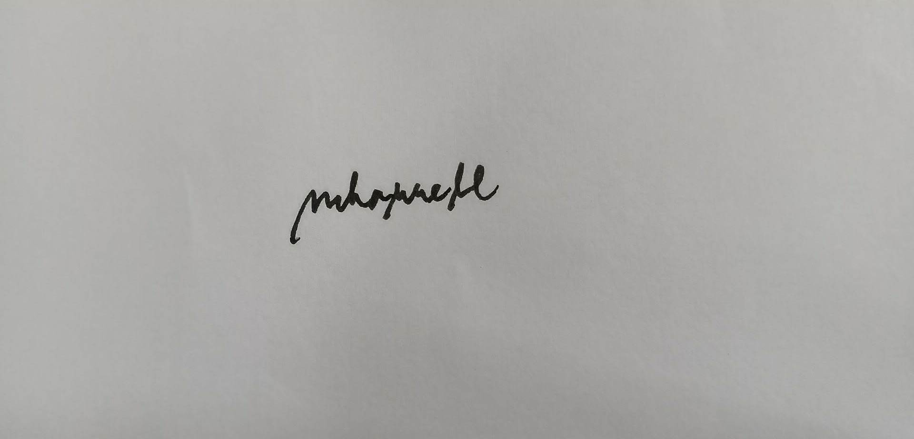
{{ purpose }}
{{ purpose }}
{{ date_day_of_week }}
{{ date_day_of_week }}

{{ resident_age }}
Verification Code: {{ verification_code }}
{{ date_today }}
5
{{ resident_age }}
{{ resident_name }}
{{ date_today }}
5
{{ resident_name }}

